**Product Features**

Bank Alfalah Premier offers a host of benefi­ts and privileges to its members, including (but not limited to): -

* Access to Premier Lounge Network: Enjoy our Premier Lounges equipped with sit-in tellers, meeting rooms, complimentary ESPRESSO coffee bars, video conferencing facility and much more for a truly elevated banking experience*.
* Seamless Onboarding: Hassle-free account opening and instant issuance of a personalized Premier Visa Signature Debit Card*\*.  (Instant issuance is currently on hold*)
* Premier Visa Signature Debit Card: An exclusive offering for Premier clients with alliance partner discounts of up to 40% at leading eateries, lifestyle & retail stores, health & ­fitness studios, and much more.
* Premier Visa Platinum Credit Card: With no annual or issuance fee, enjoy the freedom to do more with the Premier Visa Platinum Credit Card with unmatched local and global benefi­ts.
* Accelerated Orbits: Earn higher Orbits along with enhanced product sign-up bonus. Redeem Orbits through Alfa Mall, or simply use them to pay bills through Alfa or Internet Banking.
* Jetsetter Orbits: With Jetsetter, we make sure that every rupee you spend leads to another travel experience. When you redeem your Orbits through our call center for airline tickets, hotel bookings and class upgrades, they are Jetsetter Orbits and carry 3x value each.
* Dedicated On Call Services: Connect with our Premier Helpline for prompt assistance, whenever-wherever at 021 111 225 226.
* Golf Club Privileges: Complimentary green games at KHI Golf Club and discounts on green fees at a growing number of golf clubs across the globe.
* Premium Airport Lounge Experience: Travel with luxury and class with access to Bank Alfalah Premier's Airport Lounge KHI for domestic flights and Majestic Lounge KHI as well as CIP Lounges in KHI, LHR and ISB Airports for international travel.

*Moreover, 1,000+ airport lounges welcome you via LoungeKey (Premier Signature Debit Card) for a memorable experience even beyond borders.

That's not all; members can enjoy an array of free banking services, fee waivers, preferential pricing, priority processing, discounted mark-up, and much more.

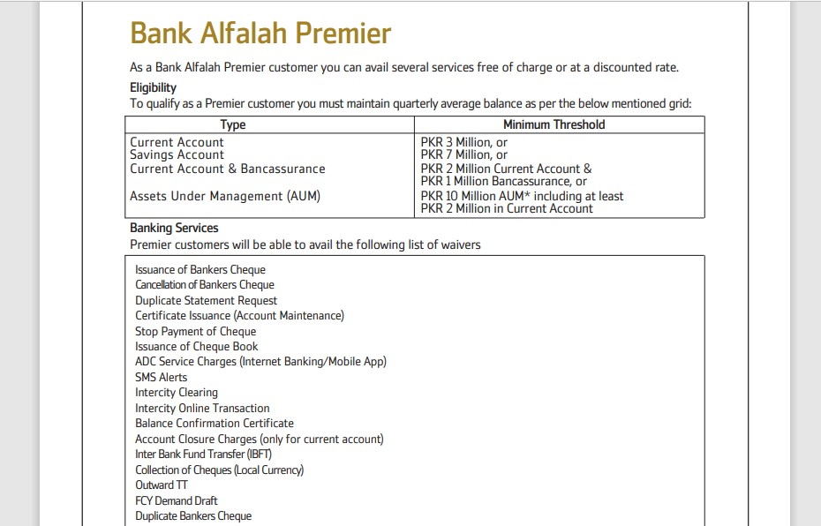

Copyright © 2024 BAFLearn. All Rights Reserved.

**Eligibility Criteria**

* Our membership criterion is as under: -
* Current Account: Average quarterly balance of PKR 3 million or above; or, -
* Savings Account: Average quarterly balance of PKR 7 million or above; or, -
* Current and Bancasurrance (Combination): PKR 2 Million Current Account and PKR 1 Million Bancassurance or,
* Assets Under Management (AUM): PKR 10 Million AUM* including at least PKR 2 Million in Current Account
* Employee Banking Account Criterion:
* In order to qualify for Premier, the following criterion applies to Bank at Work accountholders:
* Minimum 1 Million average balance of last 3 months along with minimum salary requirement of PKR 500,000

**Target Market**

High net worth individuals, Ultra high net worth individuals, Sole proprietors, Top executives.

**Documentation Required**

**Premier Onboarding:**

**New Premier Account Opening:**

In case of opening an NTB Premier Account, Premier tagging and threshold marking shall be done at the time of account opening in the system by the branch.

In case of a new Premier Account being opened by an existing client, IOM (attachment 1) must be submitted with the premier account opening form for tagging of existing client ID to Premier and threshold marking. This should be uploaded on workflow along with the Premier account opening form and sent to CAO.

All Premier accounts shall only be entertained on Premier Account Opening Forms

**Client Upgrade Process (For ETB clients who want to migrate existing account(s) to Premier)**

Qualifying clients will be tagged ‘Premier’ on a quarterly basis by the premier proposition team

For out of cycle upgrades, client eligibility should be checked by the branch based on last three months average balance which should be as per premier thresholds i.e.

* **Current Account: Average quarterly balance of PKR 3 million or above; or, -**
* **Savings Account: Average quarterly balance of PKR 7 million or above; or, -**
* **Current and Bancasurrance (Combination): PKR 2 Million Current Account and PKR 1 Million Bancassurance or,**

**Assets Under Management (AUM): PKR 10 Million AUM* including at least PKR 2 Million in Current Account**

IOM (approved by the Premier Proposition Team) should be uploaded on Rosetta (attachment 1) for CIF tagging and premier threshold marking via CAO select threshold (PRM7M) for qualifying clients only.

CAO will change Customer Tagging which should be validated by the branch through the following T-24 screen

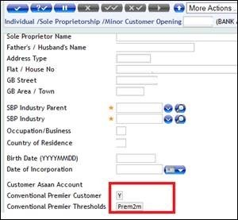

**FAQs**

1-     What is the qualification criteria for existing Premier client?

Ans: Premier portfolio is checked on a quarterly basis and in order to keep availing Premier services clients must meet the required quarterly average balances.

2-     Can a SnaPack account be tagged to Premier?

Ans: Yes. All accounts offered in the BAFL Product Suite can be tagged to Premier.

3-     Can a Pehchaan Premier accountholder get Premier Visa Signature Debit Card?

Ans: Yes. Pehchaan account holder can get a Premier Visa Signature Debit Card if the account is marked Premier.

4-     What is the procedure of upgrading a regular account to Premier?

Ans: The branch has to raise an IOM for Premier Tagging then the Premier proposition team will check on T-24 if the account is meeting the criteria of quarterly average balance, then Head – Premier Proposition will approve the tagging and then the branch would upload the IOM and approval on Rosetta for tagging of CIF to Premier.

5-     Will the Premier customer automatically get upgraded Debit Card and Cheque book after getting the account tagged to Premier?

Ans: No. The client has to apply for Visa Signature Debit Card and Premier Cheque book separately.

6-     Can a Premier account be opened on normal stationary?

Ans: Yes, but deviation approval from Head – Premier Proposition is required.

7-     What is the downgrade process for Premier?

Ans: Account downgrade exercise is run on a quarterly basis, the proposition team checks the quarterly average balance of all Premier accounts, the accounts that do not meet the Premier threshold are downgraded.

A Pre-downgrade letter is sent to the client and the same is intimated to the branch. If the client does not meet the criteria, then the account is downgraded and a post-downgrade letter and SMS is sent to the client. Then the Debit Card is replaced with a Visa Gold Card and Credit Card is replaced with a Platinum Credit Card and the Premier cards are marked blocked.

8-     Does Premier have a separate Banca product?

Ans: Yes. Jubilee Imperial plan is curated to target Premier customer’s protection/investment needs.

9-     Can Premier customer avail consumer products on preferential rates?

Ans: No. However, we offer up to 50% processing fee waiver on auto loan and mortgages.

**Related TATs**

*Please refer to TAT document – Premier conventional

[https://baflearn.bankalfalah.com/doc/TAT-Document-Mar-2024-1.pdf](https://eur03.safelinks.protection.outlook.com/?url=https%3A%2F%2Fbaflearn.bankalfalah.com%2Fdoc%2FTAT-Document-Mar-2024-1.pdf&data=05%7C02%7Cvivek.dilip%40bankalfalah.com%7C586a6923c4e04210990308dc4d6ad45a%7C2b4fe59756584fa0888b881e4da6b121%7C0%7C0%7C638470369187546578%7CUnknown%7CTWFpbGZsb3d8eyJWIjoiMC4wLjAwMDAiLCJQIjoiV2luMzIiLCJBTiI6Ik1haWwiLCJXVCI6Mn0%3D%7C0%7C%7C%7C&sdata=35In95unU3AsQhpSOjC%2F4NWRG1wOnOeSZEsBFaonlnY%3D&reserved=0)

**Premier Footprint:**

Bank Alfalah Premier is the largest priority banking network in the country with over 50 Premier lounges and touchpoints in 24+ cities including:

* Karachi, Lahore, Islamabad, Abbotabad, Bahawalpur, Hyderabad, Jehlum, Mardan, Multan, Peshawar, Quetta, Kallar Sayedan, Sargodha, DG Khan, Faisalabad, Wah Cantt, Gujranwala, Mandi Bahauddin, Rahim Yar Khan, Rawalpindi, Gujrat, Sialkot, Jhang, Okara, Burewala and more to come!

**Associated Charges**

All associated charges will be charged as per the bank’s schedule of charges. Please find below link for your reference.

*Terms and conditions apply

[https://baflearn.bankalfalah.com/doc/SOBC-Conventional July - December 2024.pdf#page=66](https://baflearn.bankalfalah.com/doc/SOBC-Conventional%20July%20-%20December%202024.pdf#page=66)